**National University of Computer and Emerging Sciences** 

# Software Engineering



**“Project Report”**

**Group Members:**

* Munam Mustafa 21I-0460
* Muzammil Hassan 21I-0631

**Degree Program:** BS-CS

**Section:** D

**Subject Name:** Software Engineering

**Date of Submission:** 05/05/2024

**Introduction:**

The annual job fair at FAST University plays a crucial role in connecting graduating students with potential employers in the IT industry. However, several challenges hinder its effectiveness, including varying levels of employer engagement, inefficient interviewee management, inadequate record keeping, insufficient student preparation, and a lack of structured feedback mechanisms.

To address these challenges, this report proposes the development of a Job Fair Management System tailored to FAST University's needs. By streamlining processes from employer registrations to student interviews and providing resources for student preparation, the system aims to enhance the overall efficiency and effectiveness of the job fair, ultimately improving job placement outcomes for graduating students.

**Project Rational:**

The development of a Job Fair Management System for FAST University is essential for several reasons:

1. Efficiency and Effectiveness: The current manual processes for organizing and managing the job fair are time-consuming and prone to errors. By implementing a digital management system, the university can streamline processes, improve coordination, and enhance the overall efficiency and effectiveness of the job fair.
2. Enhanced Employer Engagement: Engaging employers is crucial for the success of the job fair. However, the current approach lacks a systematic method for reaching out to potential employers and managing their participation. A dedicated management system will enable the university to efficiently communicate with employers, facilitate registrations, and allocate resources, thereby enhancing employer engagement.
3. Improved Student Experience: Graduating students rely on the job fair to connect with potential employers and secure job opportunities. However, the current system lacks organization, resulting in a disjointed experience for students. By implementing a centralized management system, students can benefit from streamlined processes, personalized scheduling, and access to resources for preparation, ultimately enhancing their overall experience.
4. Data Management and Analysis: The lack of a centralized system for record-keeping and data management poses challenges in tracking student participation, interview outcomes, and employer feedback. A dedicated management system will enable the university to maintain comprehensive records, analyze data, and derive valuable insights to improve future job fairs and student outcomes.
5. Continuous Improvement: By implementing a digital management system, FAST University demonstrates its commitment to continuous improvement and innovation in facilitating job placements for graduating students. The system will provide a scalable platform that can be adapted and enhanced over time to meet evolving needs and challenges.

**Project Architecture:**

The Job Fair Management System is designed to facilitate the organization and coordination of job fairs, connecting graduating students with potential employers in the IT industry. The architecture of the system is structured as follows:

1. Presentation Layer:
   * The presentation layer serves as the user interface through which students, employers, and administrators interact with the system.
   * Implemented using HTML, CSS, JavaScript, and Bootstrap framework to create a visually appealing and intuitive interface.
   * Provides features such as registration forms, job postings, interview scheduling, and feedback mechanisms for a seamless user experience.
2. Business Logic Layer:
   * The business logic layer contains the core functionality of the Job Fair Management System.
   * Developed using PHP, a server-side scripting language known for its ease of use and compatibility with various web servers.
   * Manages the application's logic, including user authentication, data processing, and interaction with external services such as payment gateways and employer databases.
   * Implements the functional requirements of the system, ensuring smooth operation and adherence to business rules and policies.
3. Data Access Layer:
   * The data access layer handles data storage and retrieval operations, storing information related to students, employers, job postings, interviews, and feedback.
   * Utilizes PHPMyAdmin as the database management tool for MySQL, a popular relational database management system.
   * Ensures efficient querying and retrieval of data to provide real-time access to information and facilitate decision-making by administrators and employers.

Reasons for Choosing Three-Tier Layered Architecture:

* Modularity and Separation of Concerns: The layered architecture provides a clear separation of concerns, allowing for independent development and maintenance of each layer.
* Scalability and Performance: The modular structure enables horizontal scaling, ensuring optimal performance and resource utilization as the system grows.
* Maintainability and Extensibility: Lower coupling between layers facilitates easier maintenance and updates, enabling changes to be made without impacting other components.
* Flexibility and Adaptability: The use of modern web technologies and scalable database solutions ensures the system's adaptability to evolving requirements and technologies.

**Product Backlog:**

*Table 1: Product Backlog*

| **ID** | **User Story** | **Estimate** | **Priority** | **Acceptance Criteria** |
| --- | --- | --- | --- | --- |
| 1 | As an employer,  I want to register for the job fair online,  So that I can participate in the event. | 3 | High | * And I know I am done when: I receive a confirmation email upon successful registration. |
| 2 | As a job fair organizer,  I want to allocate venues to employers based on  their preferences and availability,  So that the event runs smoothly. | 5 hours | High | * And I know I am done when: All employers are assigned appropriate venues. |
| 3 | As a student, I want to schedule interviews with companies of my choice online, so that I can manage my interview appointments efficiently. | 8 hours | High | * And I know I am done when: I receive confirmation of the interview slot reservation. |
| 4 | As a student, I want to submit my resume online to potential employers, So that they can review my qualifications before the job fair. | 5 hours | High | * And I know I am done when: I receive a confirmation of resume submission. |
| 5 | As a student, I want to view and sign up for workshops on resume writing and interview techniques,So that I can enhance my job readiness skills. | 3 hours | Medium | * And I know I am done when: I receive a confirmation of workshop registration. |
| 6 | As an employer, I want to provide structured feedback on students' interview performance, So that they can improve their employability. | 3.5 hours | High | * And I know I am done when: I submit the feedback form. |
| 7 | As a job fair organizer, I want to match interview slots between students and employers efficiently, So that there is an even distribution of interviews. | 8 hours | High | * And I know I am done when: All students and employers are matched for interviews. |
| 8 | As a student, I want to manage my profile information, including contact details and academic qualifications, So that employers have accurate information about me. | 5 hours | Medium | * And I know I am done when: My profile is updated with the latest information. |
| 9 | As an employer, I want to manage my profile information, including company details and job openings, So that students have accurate information about my company. | 5 hours | Medium | * And I know I am done when: My profile is updated with the latest information. |
| 10 | As an employer,  I want access to a dashboard where I can review student resumes, So that I can shortlist candidates for interviews. | 5 hours | High | * And I know I am done when: I can view and filter   student resumes based on criteria. |
| 11 | As a job fair organizer,  I want to track interview results and feedback for  each student,  So that I can assess the success of the job fair. | 8 hours | High | * And I know I am done when: All interview results are recorded accurately. |
| 12 | I want to view feedback from employers on my  interview performance,  So that I can identify areas for improvement. | 3 hours | Medium | * And I know I am done when: I can access and view my feedback. |
| 13 | As a job fair organizer,I want access to analytics on employer engagement and participation, So that I can improve future job fair planning. | 5 hours | Medium | * And I know I am done when: I can generate and view analytics reports. |
| 14 | As a job fair organizer,I want access to analytics on student engagement and participation, So that I can assess the effectiveness of student outreach efforts. | 5 hours | 14 | * And I know I am done when: I can generate and view analytics reports. |
| 15 | As a job fair organizer, I want to send automated email notifications to students and employers regarding important  updates and deadlines, So that they are well-informed about the event. | 3 hours | High | * And I know I am done when: All email notifications are sent out timely. |
| 16 | As a student,  I want to receive reminders for my interview appointments,So that I don't miss any scheduled interviews. | 3 hours | Medium | * And I know I am done when: I receive reminders prior to each interview. |
| 17 | As a student, I want access to a library of resume templates,So that I can create professional resumes easily. | 3 hours | Medium | * And I know I am done when: I can browse and select from a variety of resume templates. |
| 18 | As a student, I want access to a library of resume templates, So that I can create professional resumes easily. | 5 hours | Medium | * And I know I am done when: All interviewers are assigned appropriate time slots. |
| 19 | As a job fair organizer, I want to reserve interview rooms for scheduled interviews, So that interviews have designated spaces. | 3 hours | Medium | * And I know I am done when: All interview rooms are reserved as per schedule. |
| 20 | As an employer, I want assistance in setting up my company booth at the job fair venue, So that I can showcase my company effectively. | 3 hours | Low | * And I know I am done when: My booth setup requirements are fulfilled. |
| 21 | As a student, I want to check the status of my registration for the job fair, So that I am aware of my participation status. | 3 hours | Low | * And I know I am done when: I can view my registration status online. |
| 22 | As a student, I want to view available interview slots for each company, So that I can schedule interviews accordingly. | 5 hours | Medium | * And I know I am done when: I can view real-time availability of interview slots. |
| 23 | As a student, I want to receive notifications of interview results, So that I am informed of my job application status. | 6 hours | Medium | * And I know I am done when: I receive notifications of interview outcomes. |
| 24 | As an employer, I want to view aggregated feedback from students on our company's booth and recruitment process, So that we can make improvements for future events. | 5 hours | Medium | * And I know I am done when: I can access and review feedback reports. |
| 25 | As a participant (student or employer), I want access to on-site support during the job fair event, So that I can address any issues or inquiries promptly. | 3 hours | Low | * And I know I am done when: On-site support staff are available and responsive during the event. |

**Gantt Chart:**

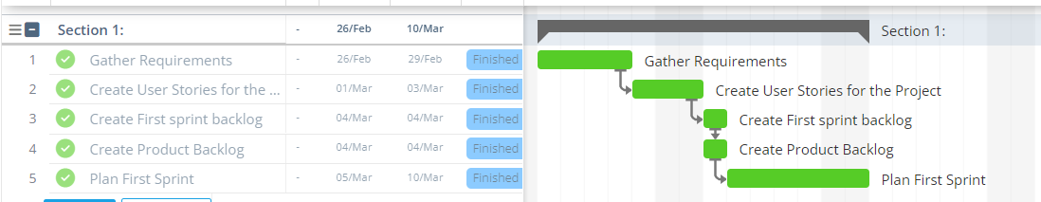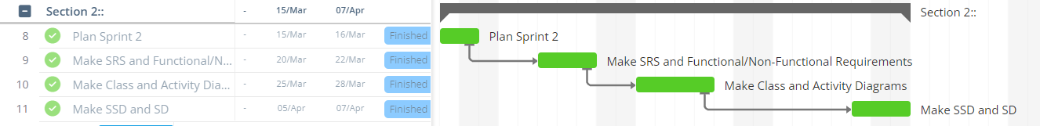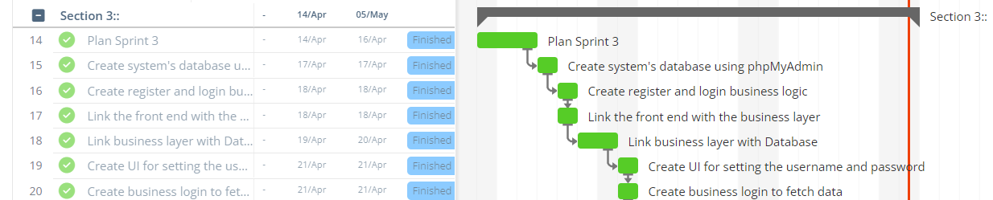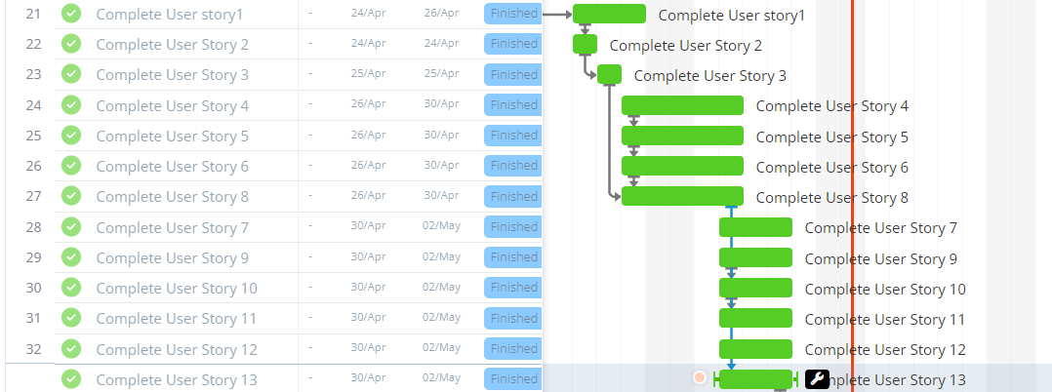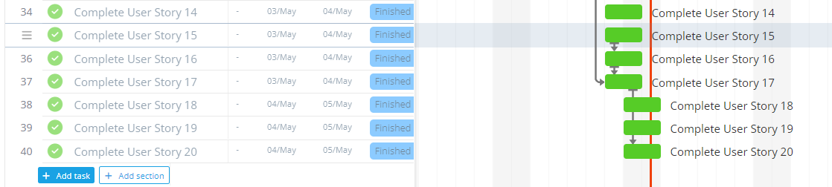

**Product Burndown Chart:**

*Figure 18: Product Burndown Chart*

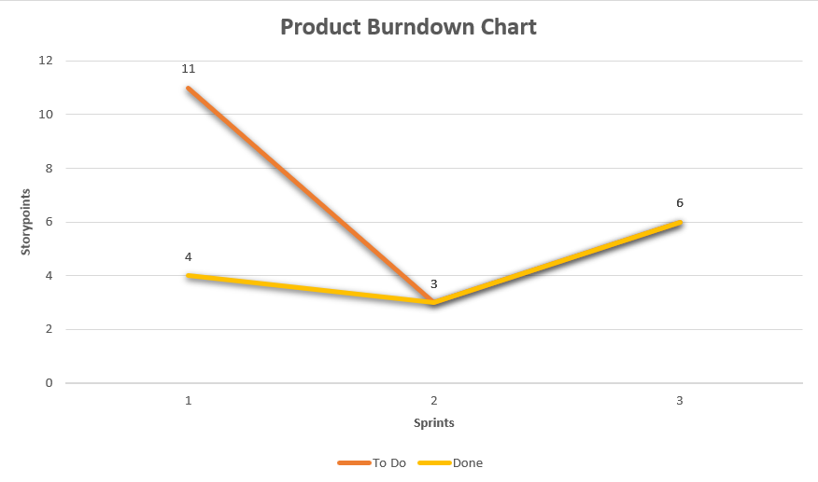

**Trello Snapshots:**

**Sprint-1:**

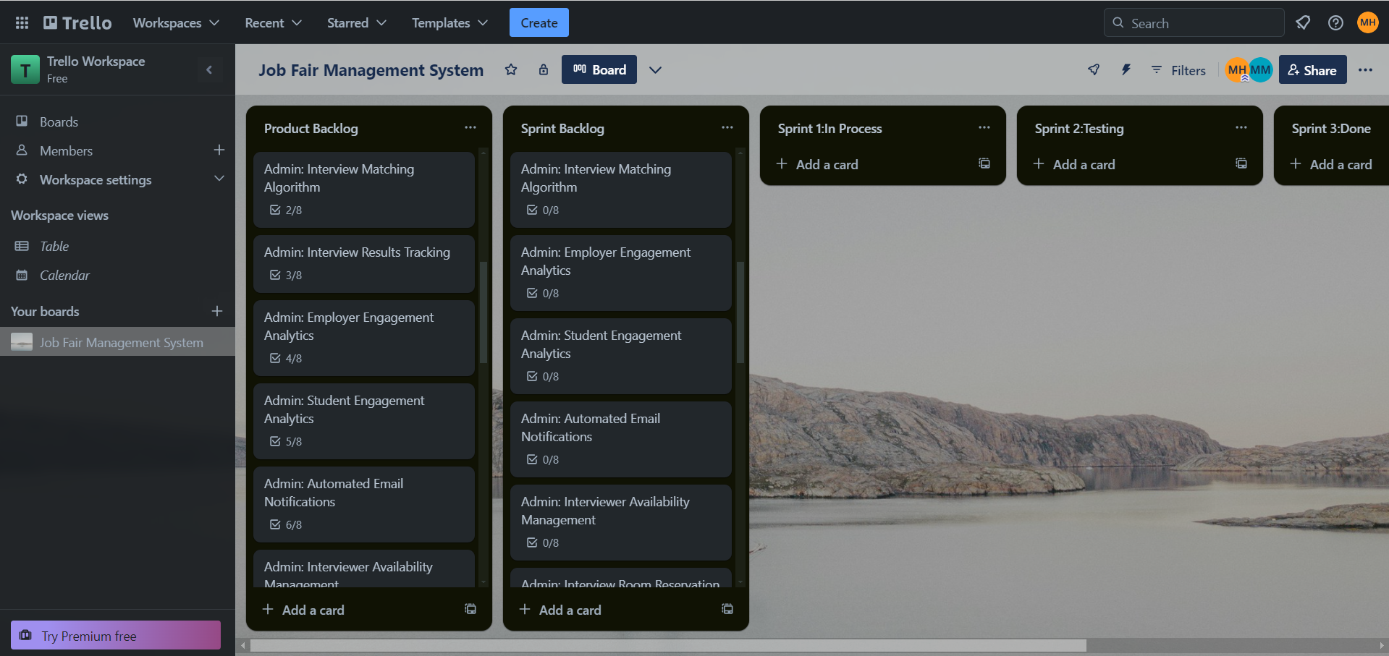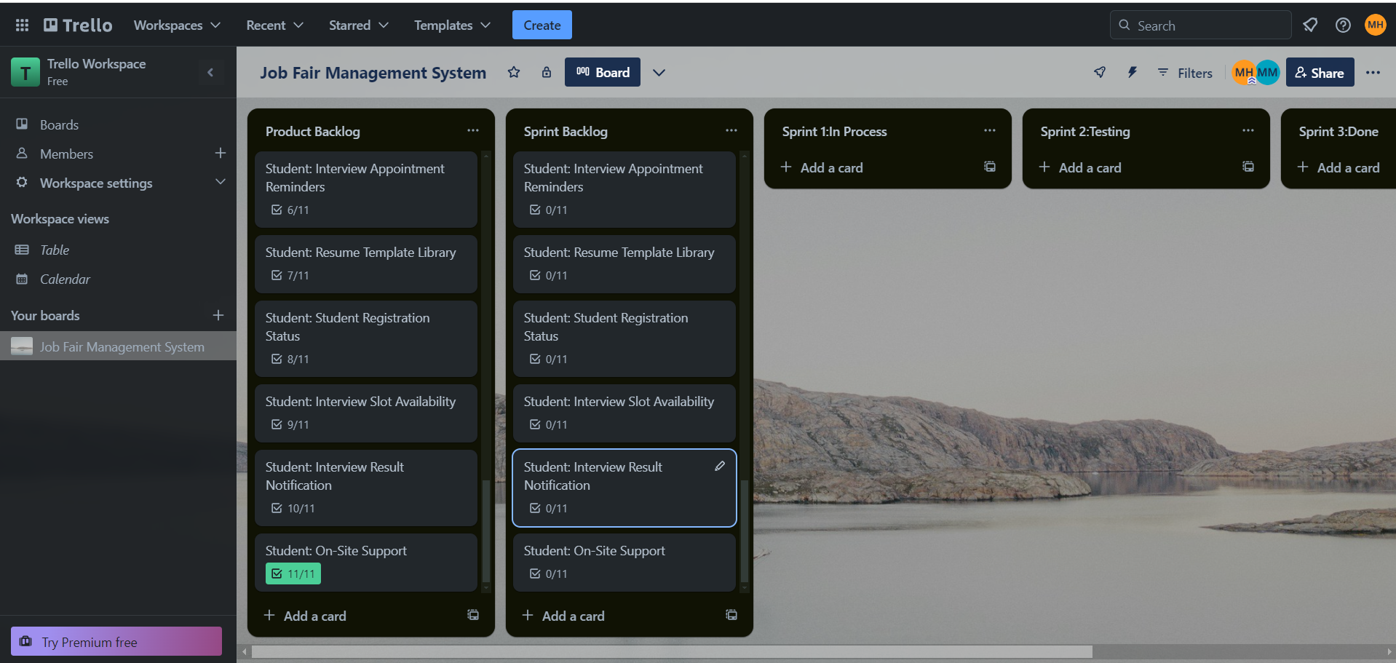

**Sprint-2:**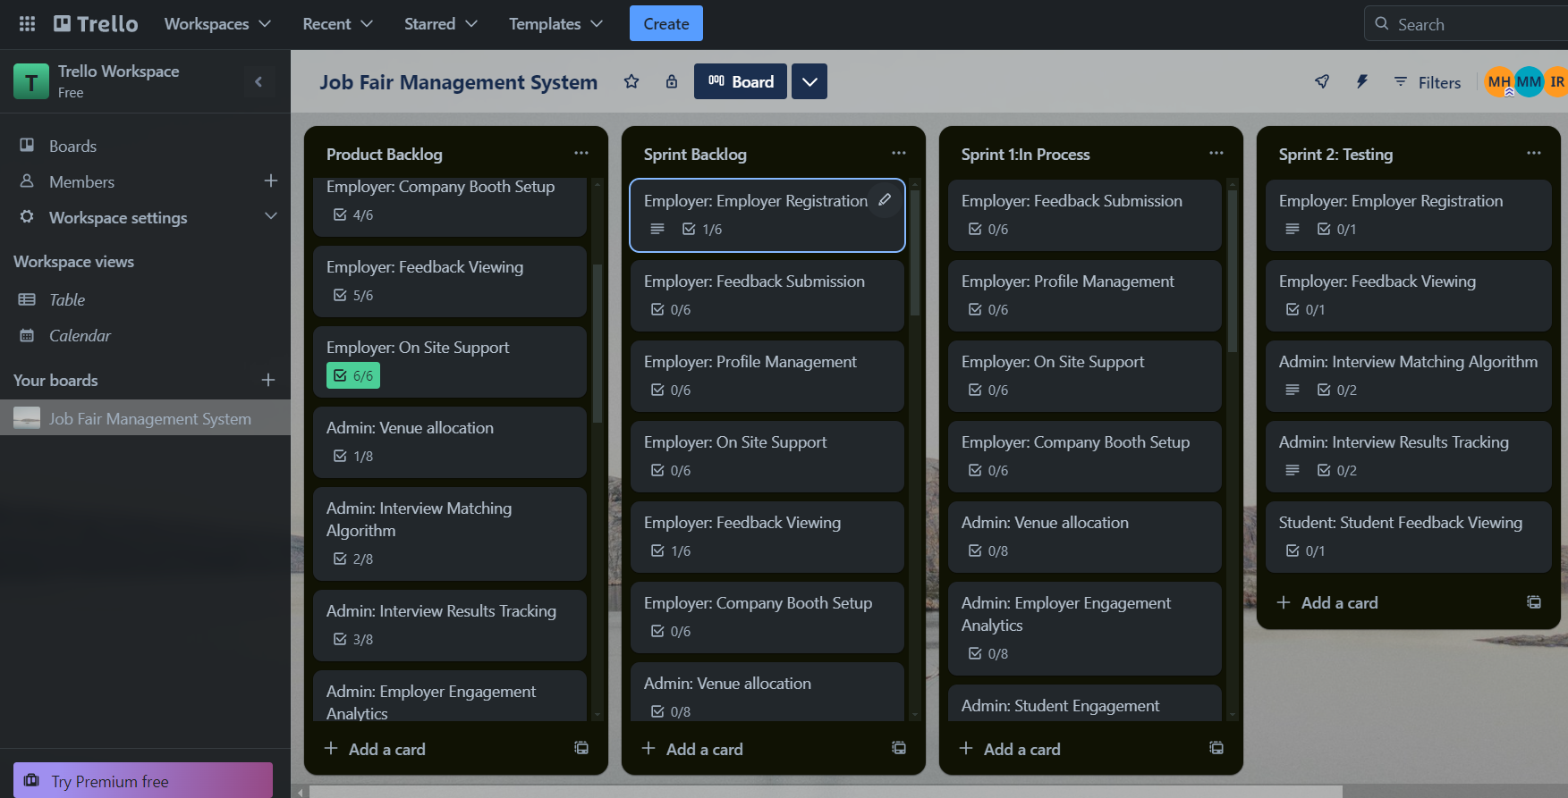

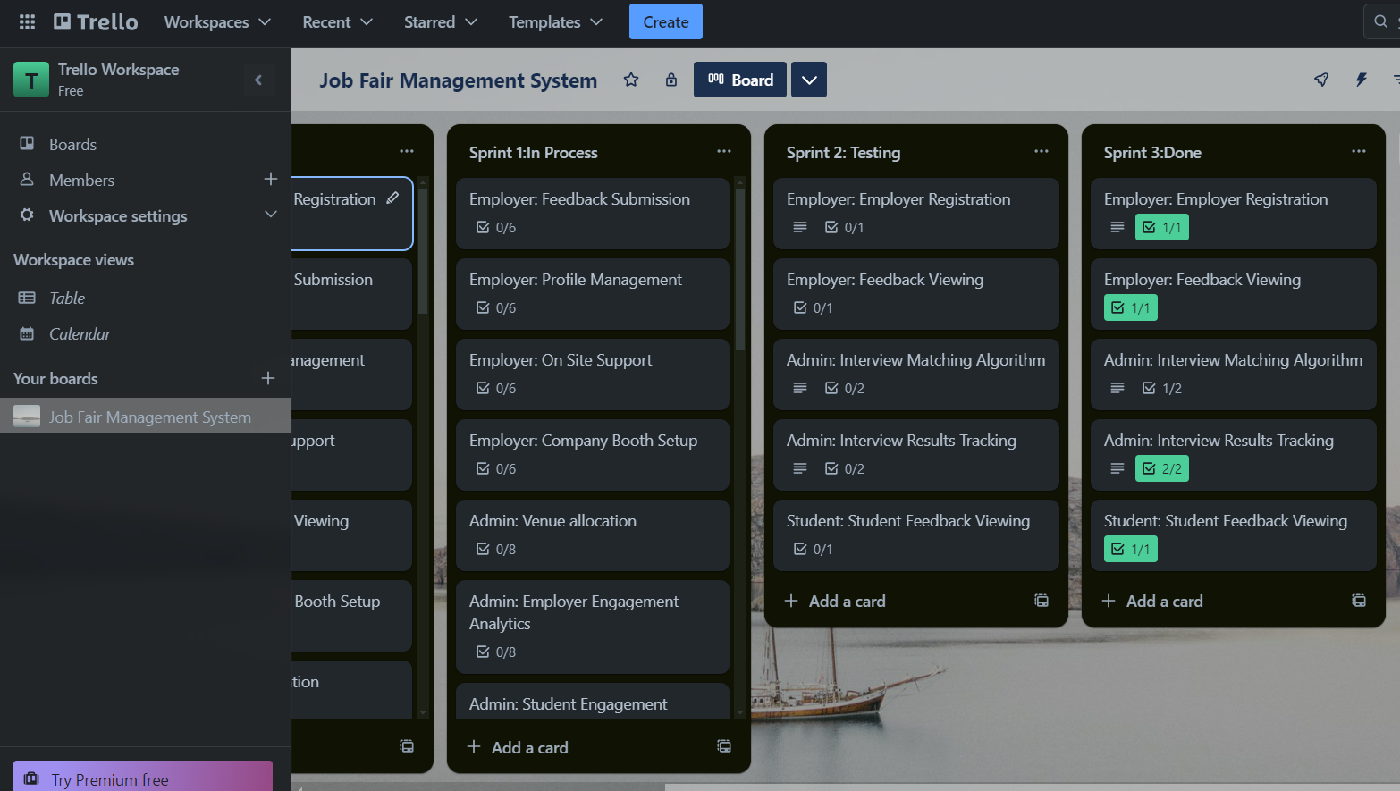

**Sprint-3 (Project Completion):**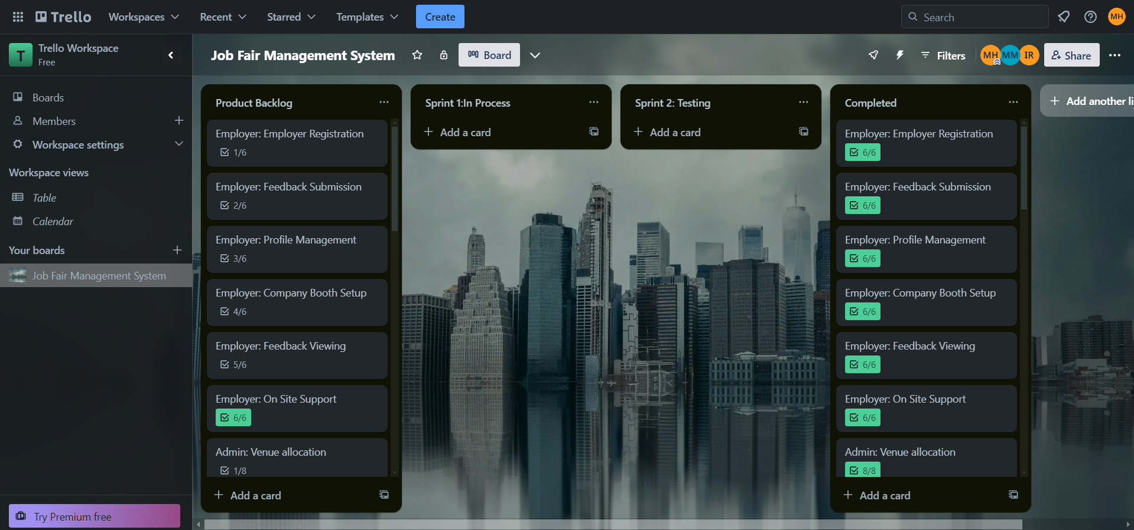

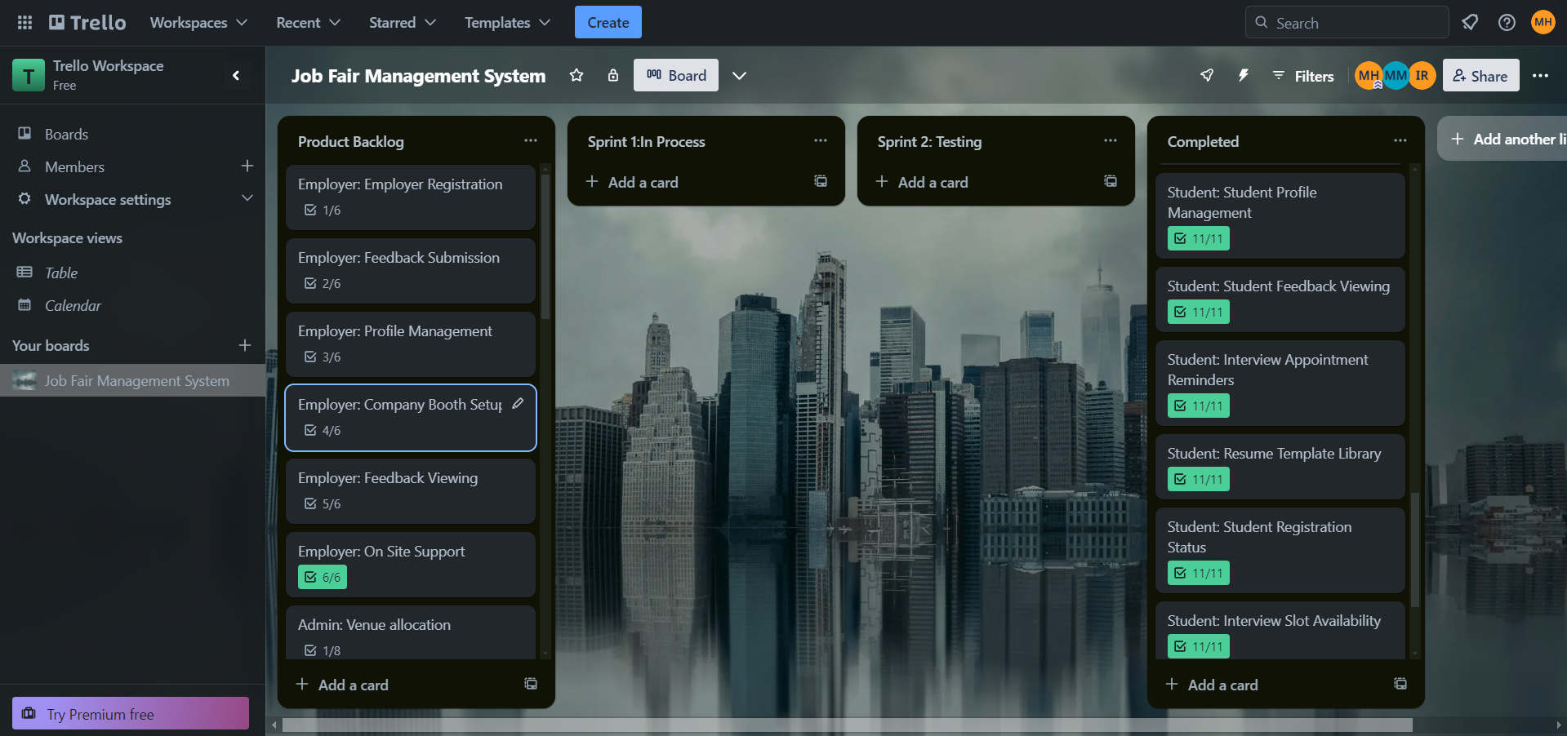

**GUI of Project:**

**Home Pages:**

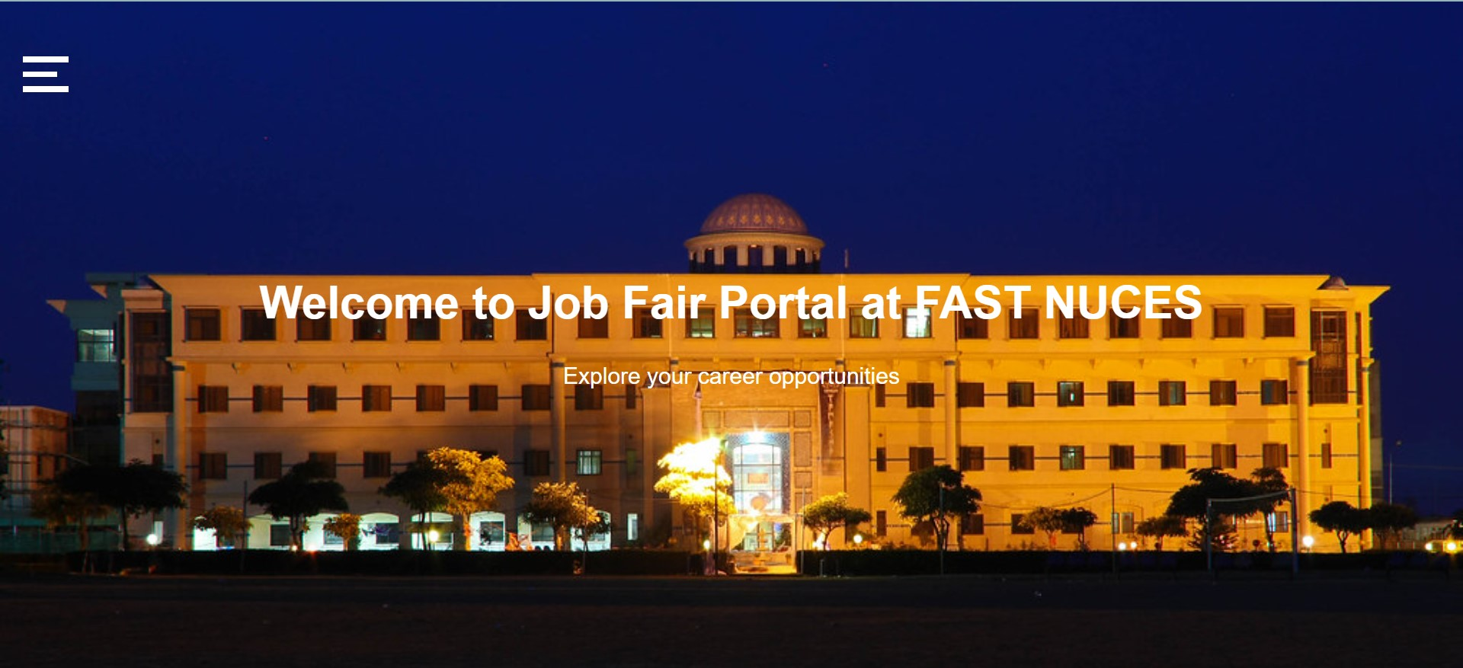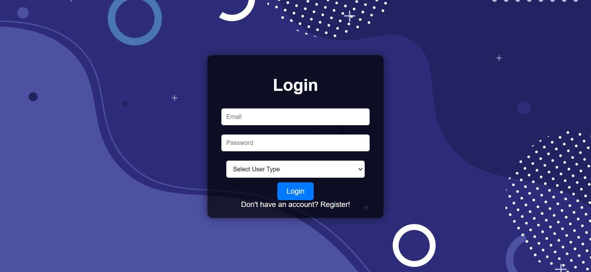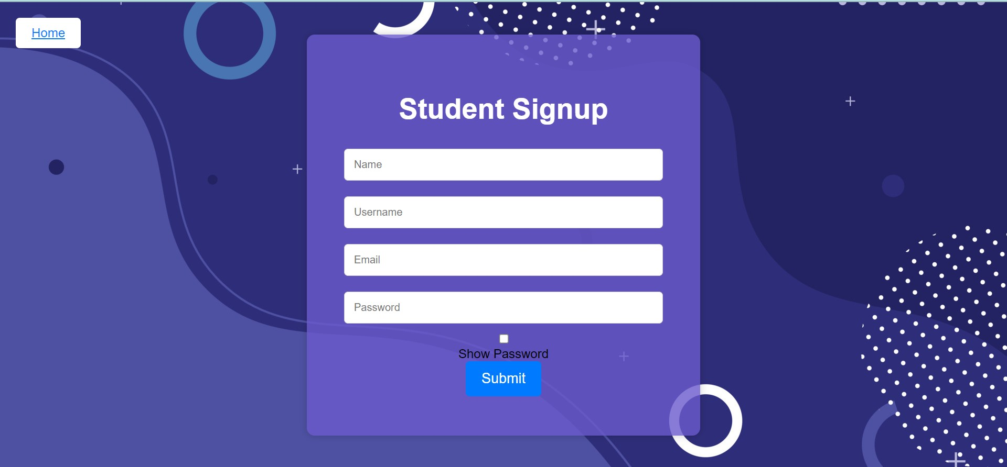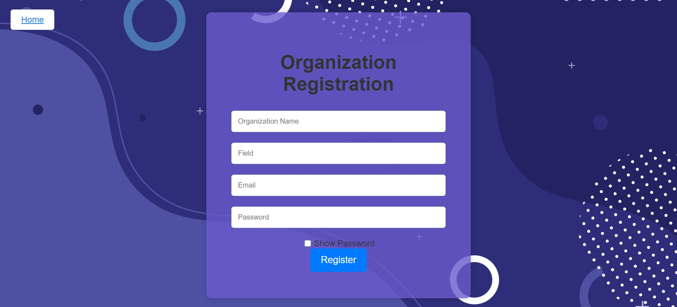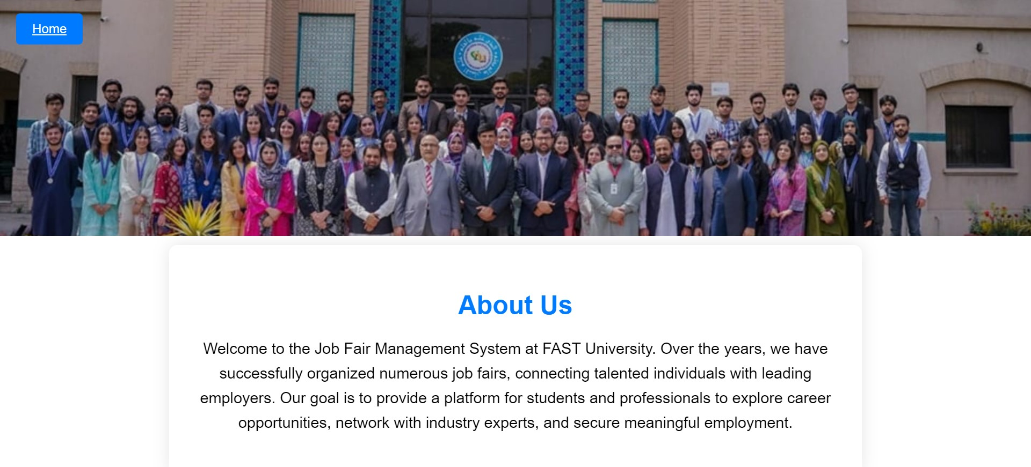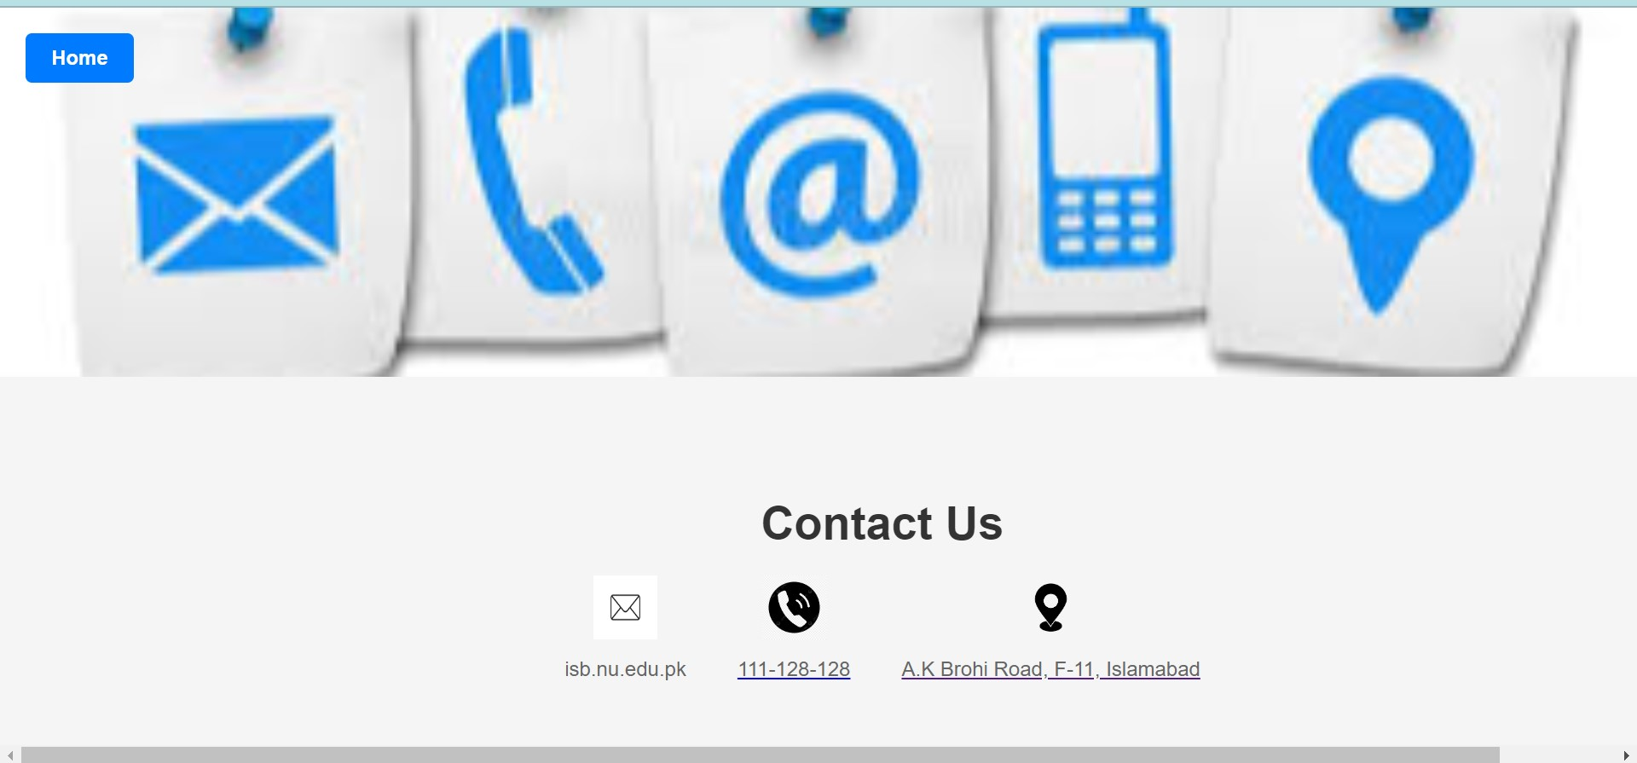

**Admin:**

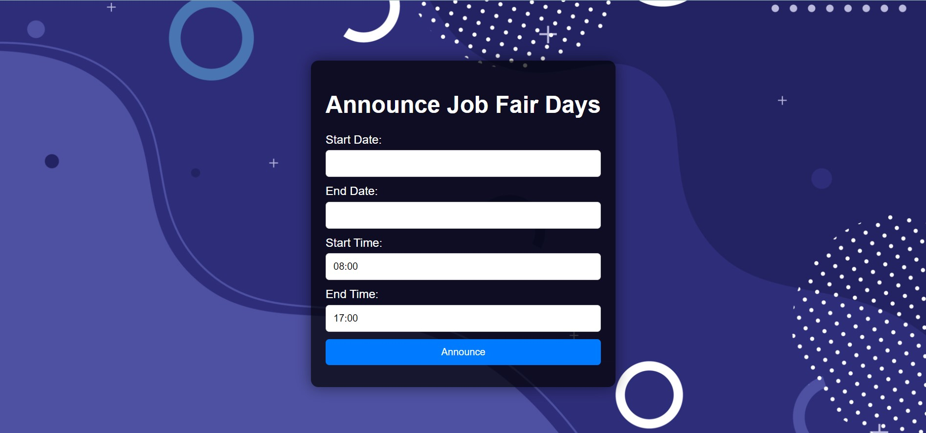

**student:**

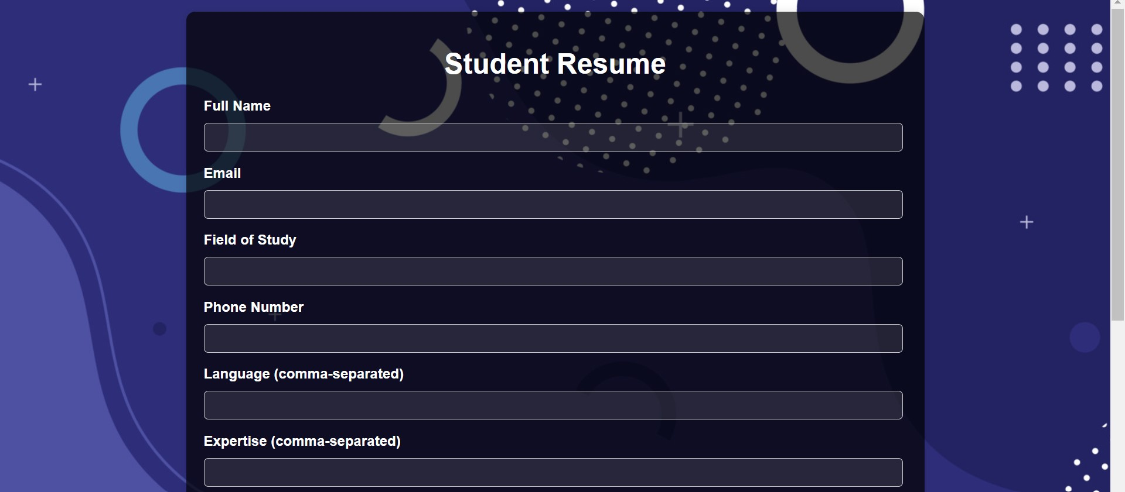

**Organization:**



**Github Images:**

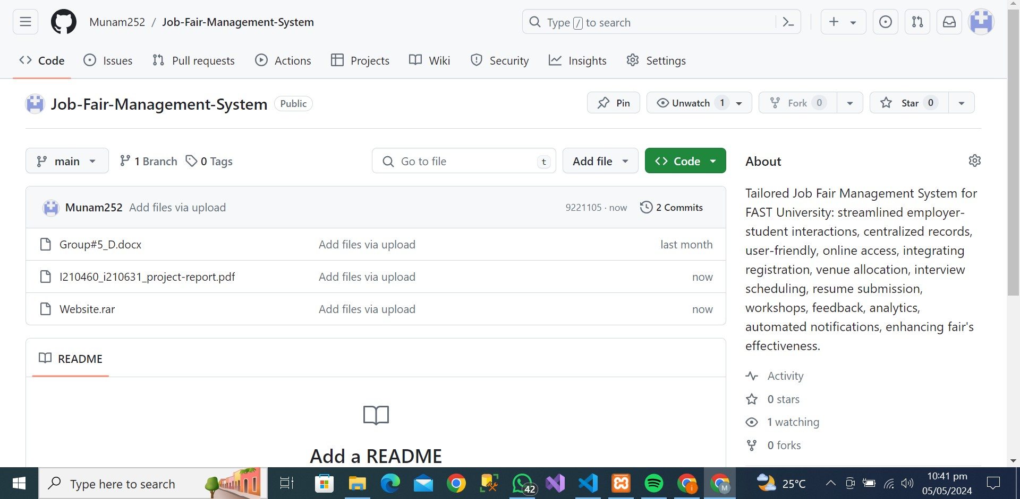

**Equivalent Class Partitions and Boundary Values:**

**User Story 1:**

Equivalent classes and identify boundary values for employer registration form

1. **Employer's Name:**
   * Equivalent Classes:
     + Valid names (e.g., John Doe, XYZ Company).
     + Invalid names (e.g., numbers, special characters).
   * Boundary Values:
     + Minimum length (e.g., 1 character).
     + Maximum length (e.g., 50 characters).
2. **Company Name:**
   * Equivalent Classes:
     + Valid company names (e.g., ABC Corporation, Tech Solutions Ltd.).
     + Invalid company names (e.g., numbers, special characters).
   * Boundary Values:
     + Minimum length (e.g., 1 character).
     + Maximum length (e.g., 100 characters).
3. **Email Address:**
   * Equivalent Classes:
     + Valid email addresses (e.g., example@example.com).
     + Invalid email addresses (e.g., missing "@" symbol, invalid domain).
   * Boundary Values:
     + Minimum length (e.g., 5 characters for "a@a.a").
     + Maximum length (e.g., 320 characters according to RFC 5321).
4. **Phone Number:**
   * Equivalent Classes:
     + Valid phone numbers (e.g., +1234567890, 123-456-7890).
     + Invalid phone numbers (e.g., alphabetic characters, incorrect format).
   * Boundary Values:
     + Minimum length (e.g., 7 digits for local numbers).
     + Maximum length (e.g., varies by country code, up to 15 digits).
5. **Industry:**
   * Equivalent Classes:
     + Valid industries (e.g., Information Technology, Healthcare).
     + Invalid industries (e.g., numbers, special characters).
   * Boundary Values:
     + Minimum length (e.g., 1 character).
     + Maximum length (e.g., 50 characters).
6. **Additional Requirements/Preferences:**
   * Equivalent Classes:
     + Valid preferences specified by the employer (e.g., booth location preference, specific job positions).
     + No preferences specified.
   * Boundary Values:
     + Minimum length (e.g., 0 characters).
     + Maximum length (e.g., 500 characters).

**User Story 2:**

**Admin Registration**

* Admin's Name:
  + Equivalent Classes:
    - Valid names (e.g., John Doe, Admin123).
    - Invalid names (e.g., numbers, special characters).
  + Boundary Values:
    - Minimum length (e.g., 1 character).
    - Maximum length (e.g., 50 characters).
* Email Address:
  + Equivalent Classes:
    - Valid email addresses (e.g., example@example.com).
    - Invalid email addresses (e.g., missing "@" symbol, invalid domain).
  + Boundary Values:
    - Minimum length (e.g., 5 characters for "a@a.a").
    - Maximum length (e.g., 320 characters according to RFC 5321).
* Password:
  + Equivalent Classes:
    - Valid passwords (e.g., Password123, @SecurePassword).
    - Invalid passwords (e.g., too short, too long).
  + Boundary Values:
    - Minimum length (e.g., 6 characters).
    - Maximum length (e.g., 50 characters).
* Confirmation Password:
  + Equivalent Classes:
    - Matching passwords.
    - Non-matching passwords.
  + Boundary Values:
    - Matching and non-matching passwords.

**User Story 3:**

Student Registration

Equivalent Classes and Boundary Values:

* Student's Name:
  + Equivalent Classes:
    - Valid names (e.g., Jane Smith, John Doe).
    - Invalid names (e.g., numbers, special characters).
  + Boundary Values:
    - Minimum length (e.g., 1 character).
    - Maximum length (e.g., 50 characters).
* Email Address:
  + Equivalent Classes:
    - Valid email addresses (e.g., example@example.com).
    - Invalid email addresses (e.g., missing "@" symbol, invalid domain).
  + Boundary Values:
    - Minimum length (e.g., 5 characters for "a@a.a").
    - Maximum length (e.g., 320 characters according to RFC 5321).
* Student ID:
  + Equivalent Classes:
    - Valid student IDs (e.g., 1234567890, S123456).
    - Invalid student IDs (e.g., alphabetic characters, incorrect format).
  + Boundary Values:
    - Minimum length (e.g., 6 characters).
    - Maximum length (e.g., 20 characters).
* University:
  + Equivalent Classes:
    - Valid universities (e.g., Stanford University, Harvard University).
    - Invalid universities (e.g., numbers, special characters).
  + Boundary Values:
    - Minimum length (e.g., 1 character).
    - Maximum length (e.g., 100 characters).

**Product Review:**

The Job Fair Management System offers valuable functionality for organizing job fair events, but there are several areas where it can be enhanced to provide an even better user experience and performance. Here's an analysis of potential improvements based on the provided sample:

1. **Integration of Advanced Technologies:**
   * Proposal: Implementing React for the graphical user interface (GUI) can significantly enhance the user experience by providing a more interactive and responsive interface.
   * Advantages: React's component-based architecture allows for the creation of reusable UI components, leading to easier maintenance and faster development. Additionally, React's virtual DOM can improve rendering performance, resulting in a smoother user experience.
   * Considerations: While React can enhance the UI, it's essential to ensure compatibility with existing backend systems and databases to maintain seamless integration and data consistency.
2. **Enhanced Layered Architecture:**
   * Proposal: Increasing the layers of the system's architecture can improve security and management capabilities.
   * Advantages: Adding additional layers, such as a service layer or security layer, can enhance the system's modularity, scalability, and security. Each layer can focus on specific functionalities, leading to better organization and maintainability of the codebase.
   * Considerations: Careful consideration should be given to the design and implementation of additional layers to avoid over-engineering and maintain performance.
3. **Mobile App Development:**
   * Proposal: Expanding the product to include a mobile app version can extend its reach and accessibility to users.
   * Advantages: A mobile app can provide users with the flexibility to access the system on-the-go, allowing for easier participation and engagement in job fair events. Additionally, mobile apps can leverage device-specific features, such as push notifications, to enhance user engagement.
   * Considerations: Developing a mobile app requires additional resources and expertise in mobile app development. Compatibility across different mobile platforms (iOS, Android) should also be considered to reach a broader audience.
4. **Performance Optimization:**
   * Proposal: While layered architecture offers benefits in terms of modularity and maintainability, it can impact system performance.
   * Advantages: By optimizing code and architecture, such as minimizing unnecessary layers or implementing caching mechanisms, performance can be improved without compromising on functionality.
   * Considerations: Performance optimizations should be carefully balanced with other considerations, such as scalability and maintainability. It's essential to conduct thorough performance testing to identify and address potential bottlenecks.